

**Monthly News Bulletin January 2025**

* **Intellectual Property Law (IPR)**



**SC Upholds Bombay HC Ruling: Intellectual Property Theft Comes Under SC/ST Act**

In a significant ruling, the Supreme Court upheld a Bombay High Court order that broadened the definition of "property" under the SC/ST Act to include intellectual property. The case involved a Dalit couple, Shiv Shankar Das and Kshipra Kamlesh Uke, whose research data was stolen from their Nagpur home. The couple sought compensation for the theft of their intellectual property under the Atrocities Act. While the Maharashtra government contested the ruling, the Supreme Court dismissed their plea, affirming that intellectual property, including data and digital material, qualifies as property under the Act. This ruling ensures that intellectual property theft involving Dalit individuals is

eligible for compensation under the SC/ST Act.

**DNPA Joins ANI’s Lawsuit Against OpenAI Over Copyright Concerns**

The Digital News Publishers Association (DNPA), representing major Indian news platforms like Indian Express, Hindustan Times, and NDTV, has filed an application in the Delhi High Court to join ANI’s lawsuit against OpenAI, accusing the company of using copyrighted content without permission to train its language models. DNPA asserts that OpenAI’s use of vast quantities of Indian news content, without licenses, harms intellectual property rights and threatens press transparency. The industry body also expresses concerns about AI’s potential to exacerbate misinformation and degrade the quality of news. Highlighting OpenAI's licensing deals with international news outlets, DNPA seeks to address the legal questions surrounding the unauthorized use of copyrighted material in AI development.

**c**

* **Constitutional Law**

**Uttarakhand Becomes First State to Implement Uniform Civil Code**

Uttarakhand has become the first state in India to implement the Uniform Civil Code (UCC), which came into effect on January 27, 2025. Chief Minister Pushkar Singh Dhami announced that the UCC aims to bring uniformity in personal civil matters, ensuring equality by eliminating discrimination based on caste, religion, and gender. The move fulfills a promise made by the Bharatiya Janata Party (BJP) during the 2022 assembly elections. The UCC will streamline laws on marriage, divorce, succession, and inheritance, making marriage registration mandatory and setting specific legal criteria for marriage. While the law applies to most residents, Scheduled Tribes and certain protected communities are excluded. This historic step aligns with Article 44 of the Indian Constitution, which calls for a Uniform Civil Code across India.



* **Arbitration Law**

**No Refund of Court Fees for Amicable Out-of-Court Settlements: Supreme Court in *Jage Ram v. Ved Kaur & Ors.***

The Supreme Court of India has ruled that litigants who resolve disputes privately, without formal Alternative Dispute Resolution (ADR) mechanisms, are not entitled to a refund of court fees. The bench, comprising Justice Pankaj Mithal and Justice Ahsanuddin Amanullah, clarified that court fees are refundable only when disputes are settled through ADR forums such as arbitration, conciliation, judicial settlement, or mediation. This decision arose from a Special Leave Petition (*Jage Ram v. Ved Kaur & Ors.*), where the petitioner sought a refund after an amicable out-of-court settlement. The Court upheld the Punjab & Haryana High Court's ruling, stating that since the case was resolved without ADR involvement, the petitioner was not entitled to a refund.



* **Criminal Law**



**Supreme Court Quashes Workplace Harassment Case, Calls It Attempt to Transform Civil Dispute into Criminal Matter**

On January 24, 2025, the Supreme Court quashed a workplace harassment case, finding that the allegations made by a female employee against her colleagues were an attempt to convert a civil dispute into a criminal matter.

The complainant had accused the appellants of various offenses, including causing hurt, insulting her modesty, criminal intimidation, and seizing her intellectual property stored on a company laptop. However, the Supreme Court observed that these allegations were based on employment disputes that had been exaggerated into a criminal case.

The Court pointed out that the criminal charges lacked merit, as the ingredients of the relevant offenses under the Indian Penal Code (IPC) were not present in the complaint. The bench, consisting of Justices Dipankar Datta and Prashant Kumar Mishra, concluded that the criminal proceedings were initiated in bad faith with the aim of pressuring the appellants into settling the employment dispute. In light of these findings, the Court quashed the pending criminal case.

**Supreme Court: Allegation of Fraud in Motor Accident Claim Requires Proof, Policy Coverage Starts from Date in Document**

In a recent ruling, the Supreme Court upheld a motor accident compensation award and emphasized that merely alleging fraud in obtaining an insurance policy is insufficient. The Court stated that fraud must be proven through proper evidence and legal procedures. The judgment came while dismissing an insurance company's appeal in the case of *National Insurance Company Ltd. v. Maya Devi and Others* (Civil Appeal Nos. 15016-15017 of 2024). The Court also clarified that the insurance policy's coverage begins from the date and time specified in the policy document. Justices Sudhanshu Dhulia and Ahsanuddin Amanullah highlighted that the insurance company failed to prove that the premium was not paid before the accident.



* **Company Law**

**Supreme Court: Resigned Director Not Liable for Cheque Issued After Resignation**

In a landmark ruling, the Supreme Court clarified that a resigned director cannot be held liable for a cheque dishonour case under **Section 141** of the Negotiable Instruments Act, 1882, if the cheque was issued after their resignation. **Section 138** of the Act deals with the offense of dishonor of a cheque, where the drawer can be penalized if the cheque is returned due to insufficient funds or if it is not honored by the bank. **Section 141** extends liability to directors and persons in charge of a company’s affairs, holding them accountable for dishonor cases if they were involved in the company's operations. However, the Court observed that once it is established that the director had already resigned and was no longer connected with the company at the time of the cheque issuance, they cannot be held responsible for the company’s financial obligations. The ruling came in the case of Adhiraj Singh v. Yograj Singh and Ors., where the appellant had resigned before the cheques were issued towards a legally existing debt. The Court quashed the Himachal Pradesh High Court’s refusal to dismiss the case against the appellant, setting aside the previous order.

Top of Form

Bottom of Form



**Supreme Court Flags Issue of Faulty Title Search Reports in Bank Loans, Calls for RBI Guidelines**

The Supreme Court in *Central Bank of India &Anr. v. Smt. Prabha Jain & Ors.* (2025 LiveLaw (SC) 96) highlighted the issue of banks sanctioning loans without proper title search reports, which may lead to legal disputes and financial loss. The Court urged the Reserve Bank of India (RBI) to develop a standardized framework for preparing title search reports before loan approvals, ensuring high-quality checks. The Court also emphasized the need for accountability, suggesting that erring bank officials who approve loans based on faulty reports should be held liable, including potential criminal action. This call for a standardized approach aims to protect public money and improve the quality of title search reports. Additionally, the Court addressed the issue of civil court procedures, stating that a plaint should not be partially rejected under Order VII Rule 11 of the CPC, and clarified that the Debt Recovery Tribunal lacks authority to hand over or restore possession of secured assets to non-borrowers.

* **Property Law**

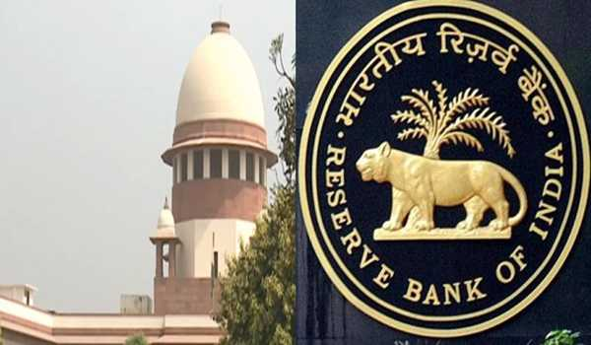

* **Cyber security & Data Protection**

**Europe Leads the Way with Digital Operational Resilience Act (DORA) for Cybersecurity**

Starting January 17, any company offering financial services in the EU or collaborating with EU-based firms must comply with the Digital Operational Resilience Act (DORA), a major regulation focusing on cybersecurity resilience. DORA aims to ensure that businesses can quickly recover from cyberattacks, emphasizing operational resilience over merely preventing attacks. This follows a familiar pattern, similar to the General Data Protection Regulation (GDPR), which reshaped global data privacy standards. Experts like Andrew Rubin, CEO of Illumio, believe DORA's focus on recovery and Zero Trust cybersecurity strategies will set a global standard for how companies approach cyber resilience.



**Parliamentary Committee Urges MHA to Take Stronger Actions Against Cybercrime**

The Parliamentary Committee on Home Affairs has urged the Ministry of Home Affairs (MHA) to implement more effective measures against the growing cybercrime problem across India. During a detailed briefing by Home Secretary Govind Mohan, it was revealed that over 38.5 million cybercrimes had been reported between 2019 and 2024, including significant cases of online financial fraud and child exploitation. The committee recommended adopting cutting-edge technologies and highlighted the need for enhanced cybercrime prevention, particularly in cases involving women. As part of its efforts, the government has released over ₹132 crore for building cyber forensic labs and training law enforcement agencies to handle these crimes more effectively.

**Parliamentary Committee Urges MHA to Take Stronger Actions Against Cybercrime**

The Parliamentary Committee on Home Affairs has urged the Ministry of Home Affairs (MHA) to implement more effective measures against the growing cybercrime problem across India. During a detailed briefing by Home Secretary Govind Mohan, it was revealed that over 38.5 million cybercrimes had been reported between 2019 and 2024, including significant cases of online financial fraud and child exploitation. The committee recommended adopting cutting-edge technologies and highlighted the need for enhanced cybercrime prevention, particularly in cases involving women. As part of its efforts, the government has released over ₹132 crore for building cyber forensic labs and training law enforcement agencies to handle these crimes more effectively.

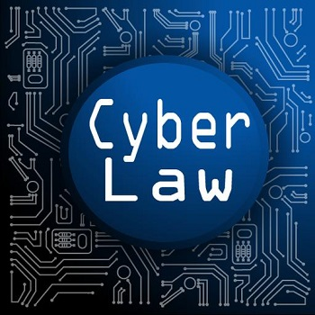

* **Miscellaneous**

**SC Rules Limitation for Stamp Duty Refund Starts from Execution of Cancellation Deed**

The Supreme Court, in *Harshit Harish Jain &Anr. v. State of Maharashtra & Ors.*, clarified that the limitation period for claiming a refund of stamp duty under the Maharashtra Stamp Act begins from the date of execution of the cancellation deed, not from its registration. The Court’s ruling came after flat owners, dissatisfied with the developer's delay, executed a cancellation deed on March 17, 2015, which was registered on April 28, 2015. Their refund claim had been rejected on limitation grounds, but the Court ruled that the right to seek a refund originates from the date of execution, ensuring their claim was within time.

